**Rizwan Hasib**

**Email:** [**rizwanhasib577@gmail.com**](mailto:rizwanhasib577@gmail.com)

**Cell: 01916029575**

**LinkedIn: https://www.linkedin.com/in/rizwan-hasib-a0962627a/**

**Nationality: Bangladeshi**

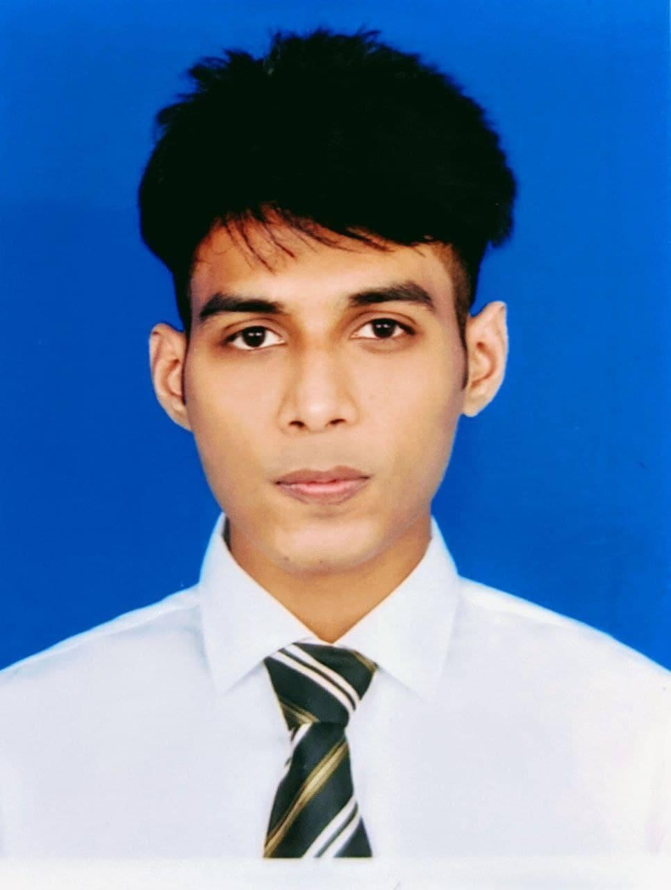

# CAREER GOAL

To work with full strength in a dynamic organization which provides new challenges that help to add value to the organizations and the individuals. Seeking a challenging career to value on time performance, where I can enhance my working skills, strength and experience which helps achieving target.

# RESEARCH STATEMENT

As a BBA student majoring in Marketing, my research interest lies in understanding the dynamic relationship between social media influencer marketing and consumer behavior. In today's digital age, social media platforms have become powerful marketing channels, and influencers have emerged as key opinion leaders who can shape consumer attitudes and purchase decisions. This research aims to investigate the effectiveness and influence of social media influencer marketing on consumer behavior.

Research Objectives:

1. To examine the role of social media influencer marketing in shaping consumer perceptions and attitudes towards brands and products.
2. To analyze the impact of different types of influencers (e.g., macro, micro, nano) on consumer engagement and purchase intentions.
3. To explore the factors that contribute to the credibility and trustworthiness of social media influencers and their impact on consumer decision-making.
4. To investigate the extent to which social media influencer marketing enhances brand awareness, brand loyalty, and customer advocacy.
5. To identify the ethical considerations associated with social media influencer marketing and their impact on consumer trust and brand reputation.

# EDUCATION

# November 2021 – November 2025 – BBA – Marketing – Independent University of Bangladesh

# June 2018 – April 2020 – HSC – Business Studies – Adamjee Cantonment College

# January 2016 – SSC – Business Studies – Adamjee Cantonment Public School

**EMPLOYMENT**

Internship at Skill & Technology as a voluntary Digital Marketing trainer (Part time)

**AWARDS AND SCHOLARSHIPS**

2018 – 2nd Prize on Business Wall Magazine – ACC IT Carnival 2018

2016 – Secondary School Certificate Merit Scholarship

# TECHNICAL SKILLS

 Expertise in Microsoft Office software’s  Digital Marketing

Adobe Photoshop, Illustrator, Premier Pro



 Graphic Designing

 Video Editing  Web Designing  Logo Designing

 Search Engine Optimization

 Business & Wedding card Designing

# Languages

* Native Bengali speaker
* Fluent in both written & spoken English
* Fluent in spoken Hindi & Urdu
* Elementary proficiency in both written & spoken French

# Interests

* Playing Football
* Reading psychological & crime thrillers
* Current Affairs & knowing about ancient history
* Collecting informations about historical warlords & their battles

**RESEARCH INTEREST- KEYWORDS**

Entrepreneurship and Small Business, Marketing and Consumer Behavior, Human Resource Management, Strategic Management, Financial Management, Operations and Supply Chain Management, International Business, Organizational Behavior, Business Ethics and Corporate Social Responsibility, Innovation and Technology Management.

**PUBLICATIONS**

JOUNAL PUBLICATIONS

[J.10] 2021 Author Name, Research Paper Title. Journal name, index and details

[J.9] 2020 Author Name, Research Paper Title. Journal name, index and details

[J.8] 2020 Author Name, Research Paper Title. Journal name, index and details

# PERSONAL INFORMATION

# Language – English (professional) Bengali (mother tongue) French (Elementary) Hindi (professional) Urdu (professional)

# Date of Birth – 06/12/2002

# Nationality – Bangladesh

# Marital Status – Unmarried

# References

Md. Moinul Islam Bhuiyan

DGM (BRB Hospitals Limited)

Contact – 01713064204

Nusrat Jahan

MBBS (Dhaka Medical College)

BCS (Health) Medical Officer (U.H.C)

Contact - 01673199754